# A:\CBHE-factori\aa-starter\Factori_soumis\communication\logo\Logo Factori 4.0.png

# From Automation and Control Training to the Overall Roll-Out of Industry 4.0 Across South-East Asian Nations

# (ASEAN FACTORI 4.0)

**PROJECT No. 609854-EPP-1-2019-1-FR-EPPKA2-CBHE-JP**

**Vocational Training (VPP-Training) for Technical Staff of Private Sector in Thailand for PLC on**

**March 24-25, 2023**

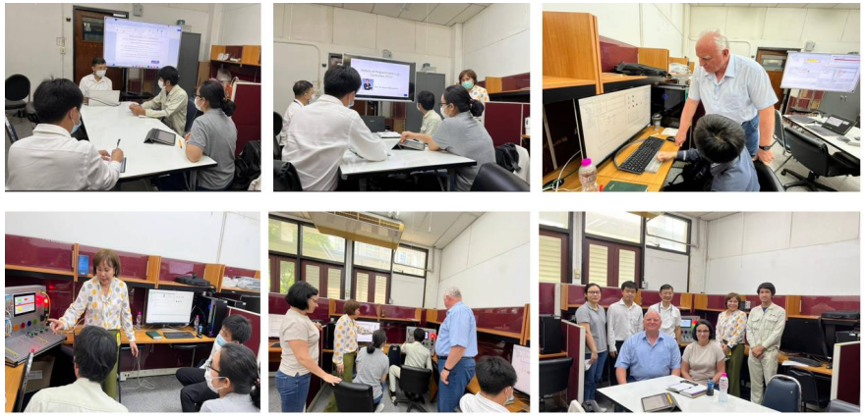

The Faculty of Engineering at Chulalongkorn University organized a Vocational Programmable Logic Controllers (PLCs) Training on March 24-25, 2023. This training was specifically designed for individuals currently working in the field of automation who are eager to gain insights into the history of Programmable Logic Controllers (PLCs), their applications, and practical exercises on utilizing PLC languages such as Ladder diagram, Function Block diagram, and Sequential Function Chart. The participants are from Thaiseisen, a former employee from Automotive company, and a former employee from control company.

Distinguished speakers from Chulalongkorn University, including Prof. David Banjerdpongchai, PhD from the Electrical Engineering Department, Prof. Paisan Kittisupakorn, PhD from the Chemical Engineering Department, and Ms. Sirikanya Singcuna from the Chemical Engineering Department, shared their expertise as trainers during this program. Their extensive knowledge and experience in their respective fields ensured a comprehensive learning experience for the participants.

Assisting in the training were Prof. Plamen Daskalov, PhD, and Assoc. Prof. Tsvetelina Georgieva, PhD, from the University of Ruse, Bulgaria. Their presence and support enriched the training sessions, providing additional perspectives and insights from their renowned institution.

Through this vocational training, participants had the opportunity to deepen their understanding of PLCs and enhance their practical skills. The comprehensive curriculum covered the historical development of PLCs, their wide-ranging applications, and hands-on exercises in utilizing different PLC languages. By actively participating in these sessions, individuals gained valuable knowledge and practical experience that could be directly applied in their work within the automation field.

We extend our sincere appreciation to all the trainers and participants for their active involvement in this Vocational Programmable Logic Controllers (PLCs) Training. Such collaborative efforts contribute to the continuous growth and development of professionals in the automation industry, ensuring their readiness to tackle the challenges of today's technological landscape.

**